Apache Kafka Tutorial
- What is apache kafka?
- It is like communication system that helps different parts of computer system exchange data by publishing and subscribing to topic.
- Why it is used ? with example
- 1. Ola driver location update
- Zomato live food tracking
- Notification system to huge user

Without Apache kafka
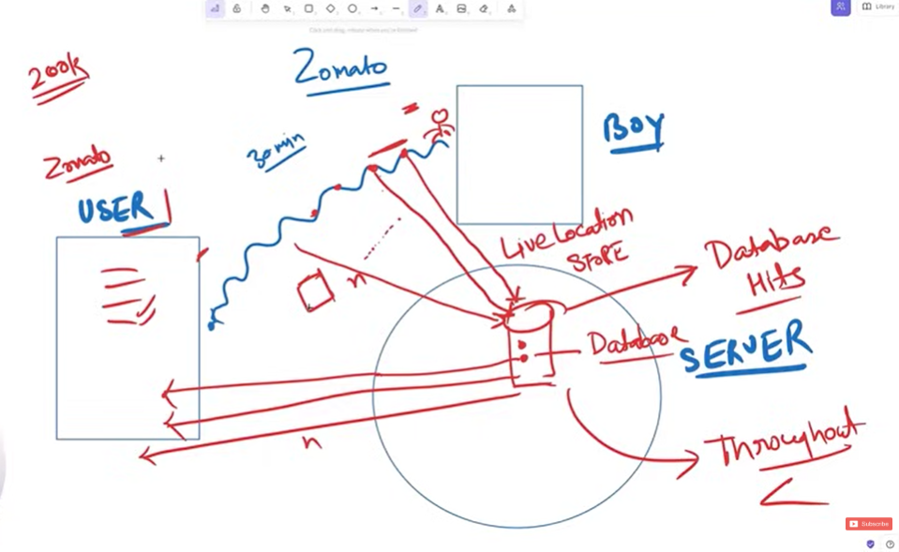
With Apache kafka
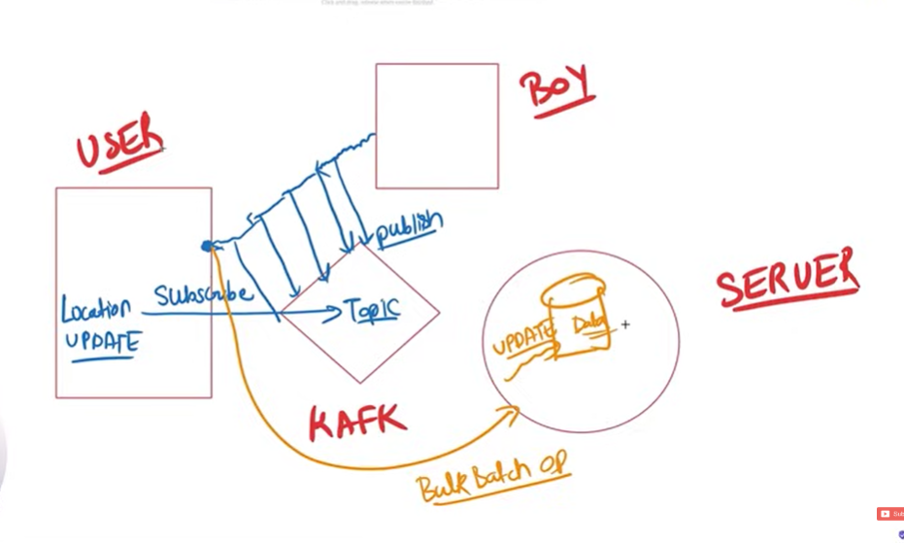
- Features of apache kafka
Why kafka is used?
- High throughput
- Fault tolerance (replication)
- Durable
- Scalable

- Architecture of kafka
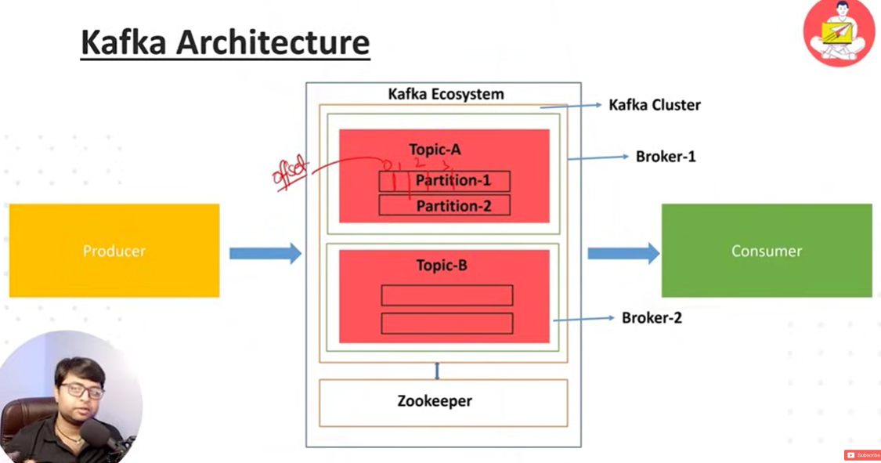

- Installation :
https://kafka.apache.org/quickstart

- Download kafka zip file from the official website
- Extract zip file
- Start zookeeper
- Start kafka server

OR Use docker
- docker pull apache/kafka-native:4.0.0
- docker run -p 9092:9092 apache/kafka:4.0.0

- Create a new topic with kafka-topics
- Produce example message with kafka console producer
- Consume the message with the kafka console consumer

Create a topic to store your events
- bin\windows\kafka-topics.bat --create --topic user-topic --bootstrap-server localhost:9092

Write some events into the topic
- bin\windows\kafka-console-producer.bat --topic user-topic --bootstrap-server localhost:9092

Read the events
- bin\windows\kafka-console-consumer.bat --topic user-topic --bootstrap-server localhost:9092

Kafka :- it is design to handle the data that is constantly being generated and needs to be processed as it come in without delay.
It ensure flow of the data from source to destination.
Example :- 1 Million like per second – 1 million calls per second, server will crash.
But kafka solves this problem.

Kafka producer store or insert that data into kafka cluster and kafka consumer consumes the data from the kafka cluster.

Zookeeper keeps track of the kafka cluster health.
Kafka connect is used to insert the data into kafka cluster from the external entity. [frpom db or file or etc without writing any code – declarative integration].

Kafka stream :- it is functionality used for the data transfer.

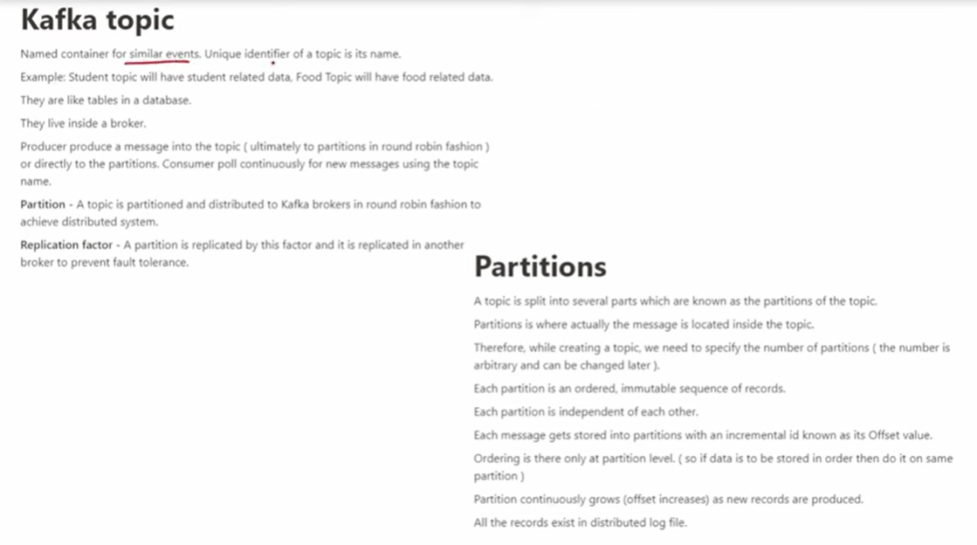

Two things :- key and value – key is optional. We can send message with keyt or without key. 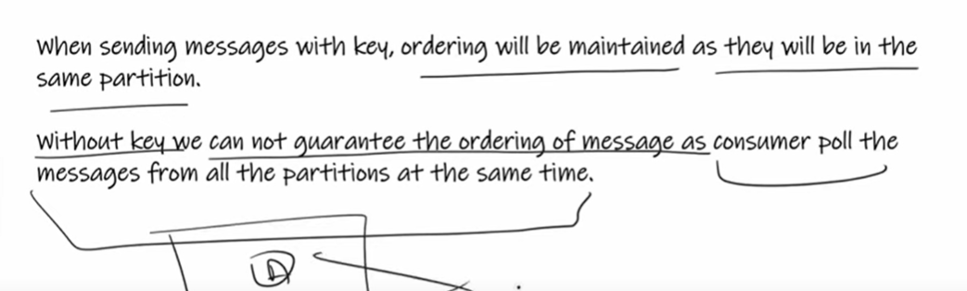

If we don’t send the key then the data will store in round robbin fastion inside the partitian [p1, p2, p3, ….. then agai p1, p2, p3…..] of the particular topic.

Commands :-
- creating topic and partition inside the topic
kafka-topics.bat --create --topic fruits –bootstrap-server localhost:9092 –replication-factor 1 --partitions 4

- creating kafka-producer
- creating kafka-consumer

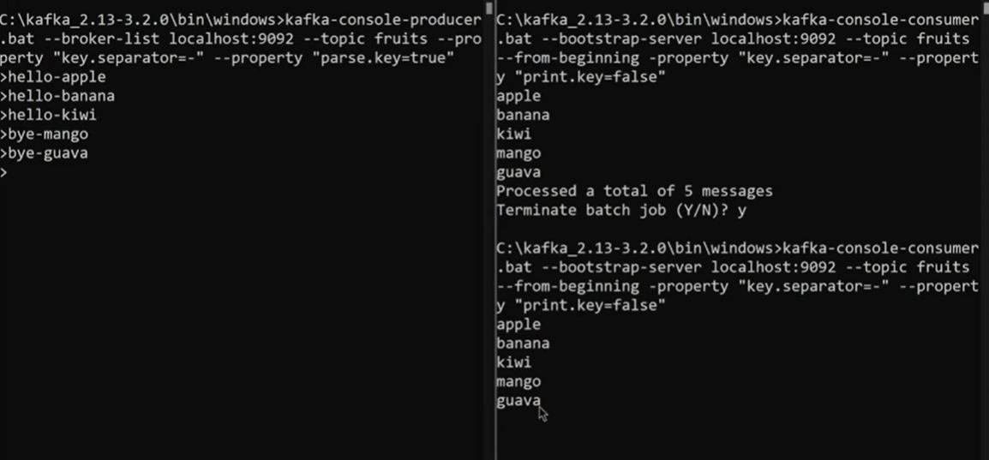

Consumer offset :- position of the consumer in the specific partition of the topic
It represent the latest message the consumer has read.
When consumer group reads message from a topic, each member of the group maintain its own offset and update it as consumes message.

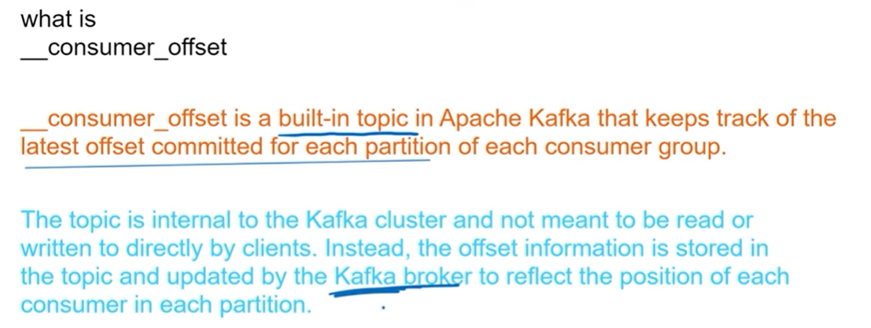

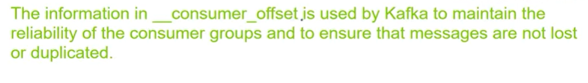
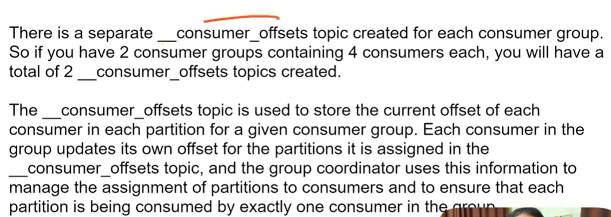

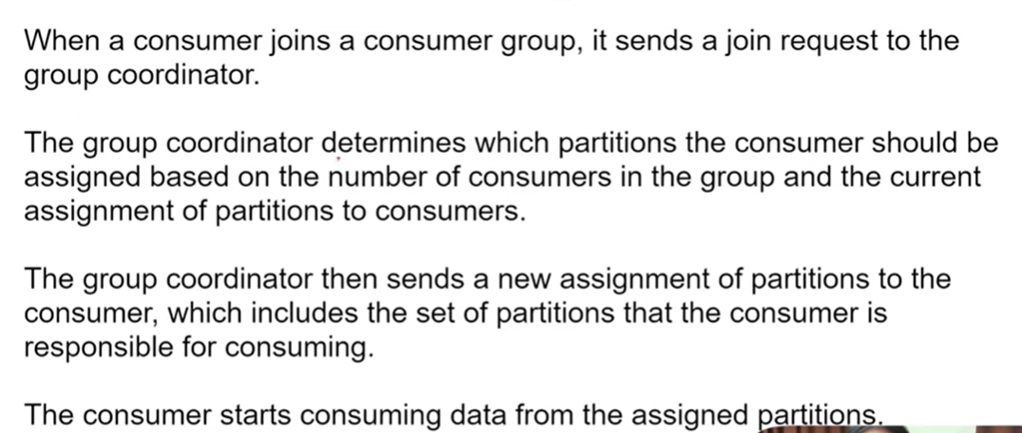

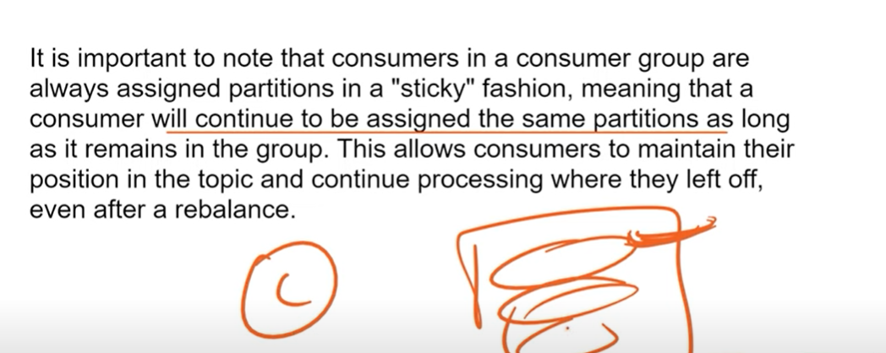
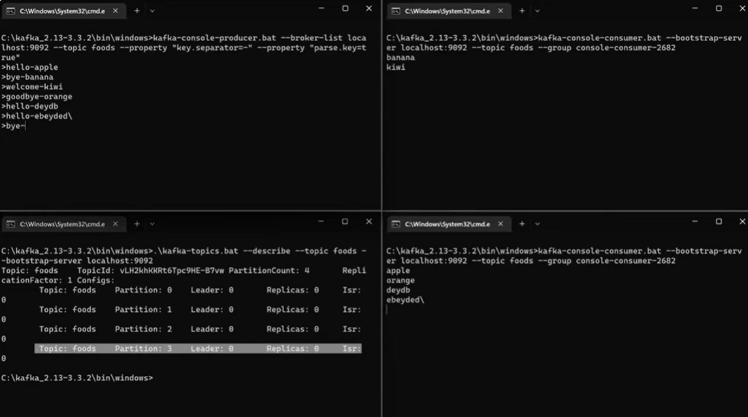

Segment and commit log and retention policy :-
Set of the messages in the partition is called segment.

Where the actual message are store?
Actual messages are store in the commit log.

Retention Policy :- it define in what specific time or size the segment should get deleted.
By default “There is time base” retention policy is there. [168 hrs – 7 days]

Kafka cluster :- it is group of kafka brokers
Replication factor gives us fault tolerance

ISR :-

Sample Apache kafka project.

- https://start.spring.io/
- Create two project :- one is producer [deliveryboy] and other is consumer [enduser]
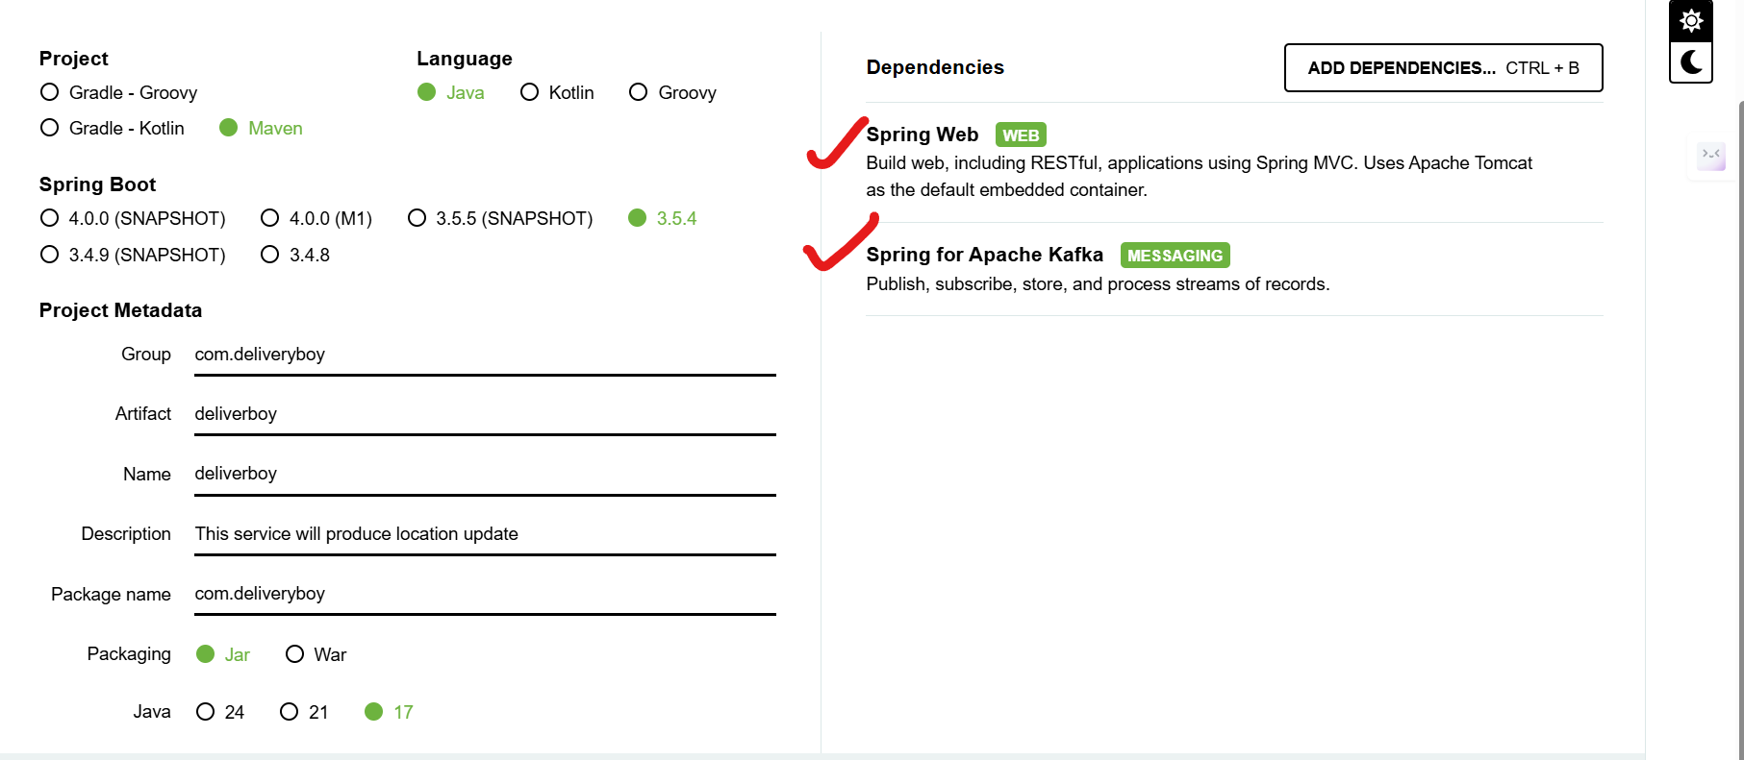
- Open both the projects in intellij idea.
- DeliveryBody :-
- Add config package and do all the configuration of apache kafka in kafkaConfig file.
  - Add or create a new topic
- Create kafkaService class in service package

